**ABSTRACT**

The goal of the project is to come up with an efficient application on home automation system. Home automation system achieved great popularity in the last decades and it increases the comfort and quality of life. In this project an overview of current and emerging home automation systems is discussed. Nowadays most home automation systems consist of a smartphone and microcontroller. A smart phone application is used to control and monitor the home appliances using different type of communication techniques. In this project the working principle of different type of wireless communication techniques such as Wi-Fi, Bluetooth, and Chatbot are studied and their features are compared with each other so the users can choose their own choice of technology to build home automation system. Moreover in this work the advantages and drawbacks of different home automation systems is discussed and highlighted.

**CONTENTS**

1. INTRODUCTION
2. OBJECTIVE
3. REQUIREMENT ANALYSIS
4. SYSTEM DESIGN
5. CIRCUIT DIAGRAM
6. BLOCK DIAGRAM
7. IMPLEMENTATION
8. INTRODUCTION TO NODEMCU ESP8266
9. TOOLS USED
10. SCREENSHOTS
11. TESTING
12. FUTURE SCOPE & MONOTIZATION
13. CONCLUSION
14. BIBLIOGRAPHY

**INTORDUCTION**

The home animation is control of home device form a central control point automation is todays facts where more things are being completed every day automatically. Usually the basic tasks of turning on or off certain device and beyond, either remotely or in close proximity. Imagine a private home equipped with motion light temperature and other sensor actuators for opining the door dimming lights with a remote control as complex as setting up a network of items in your home (such as thermostat, security system lighting and appliances) that can be programmed using a main controller.

The basic idea of home automation is to employ sensor and control system to monitor dwelling and accordingly adjust the various mechanism that provide heat ventilation lighting and more economical dwelling.

other service. The automated “intelligent” home can provide a safer more comfortable

Article history:

Received (May 12, 2017), Review Result (July 23, 2017), Accepted (August 18, 2017)

Home automation using IOT application

2 Gaurav panwar, Rajat maurya, Rajesh rawat, Rohit kanswal and Praful Ranjan

In an intelligent home automation system there are many possible solution for how and form where to control the automation system and single device a user interface can be a computer-based system a mechanical switch a single light a loudspeaker with a microphone or a some kind of personal remote controller using normal PC, laptop or

table PC by stand alone software or web-based user interface. In the near future all electronic appliances in a home will be networked.

The internet of things (IOT) is the network of physical objects or “Things”

embedded with electronics, software, sensors and network connectivity, which enable these objects to collect and exchanging data. IOT allows objects to be sensed and controlled remotely across existing network infrastructure, creating opportunity for more direct integration between the physical world and computer based system, and resulting in improve efficiency, accuracy and economic benefits.

**OBJECTIVE**

The main objective of this project is to build a smart home device which can be used to control the home appliances via internet. The home automation device that you build can be integrated with almost all the home appliances and can be used to control them remotely from any part of the world.

To facilitate the wireless connectivity with the system, the Arduino Uno will be embedded with a Wi-Fi module. This establishes the internet connection to the system and all the home appliances can in turn be connected and controlled by internet.

**REQUIREMENT ANALYSIS**

## **HARDWARE REQUIREMENTS**

* NodeMCU ESP8266
* Relay
* Breadboard
* Jump wires

## **SOFTWARE REQUIREMENTS**

* Arduino IDE
* Facebook Messenger

**SYSTEM DESIGN**

1. CIRCUIT DIAGRAM

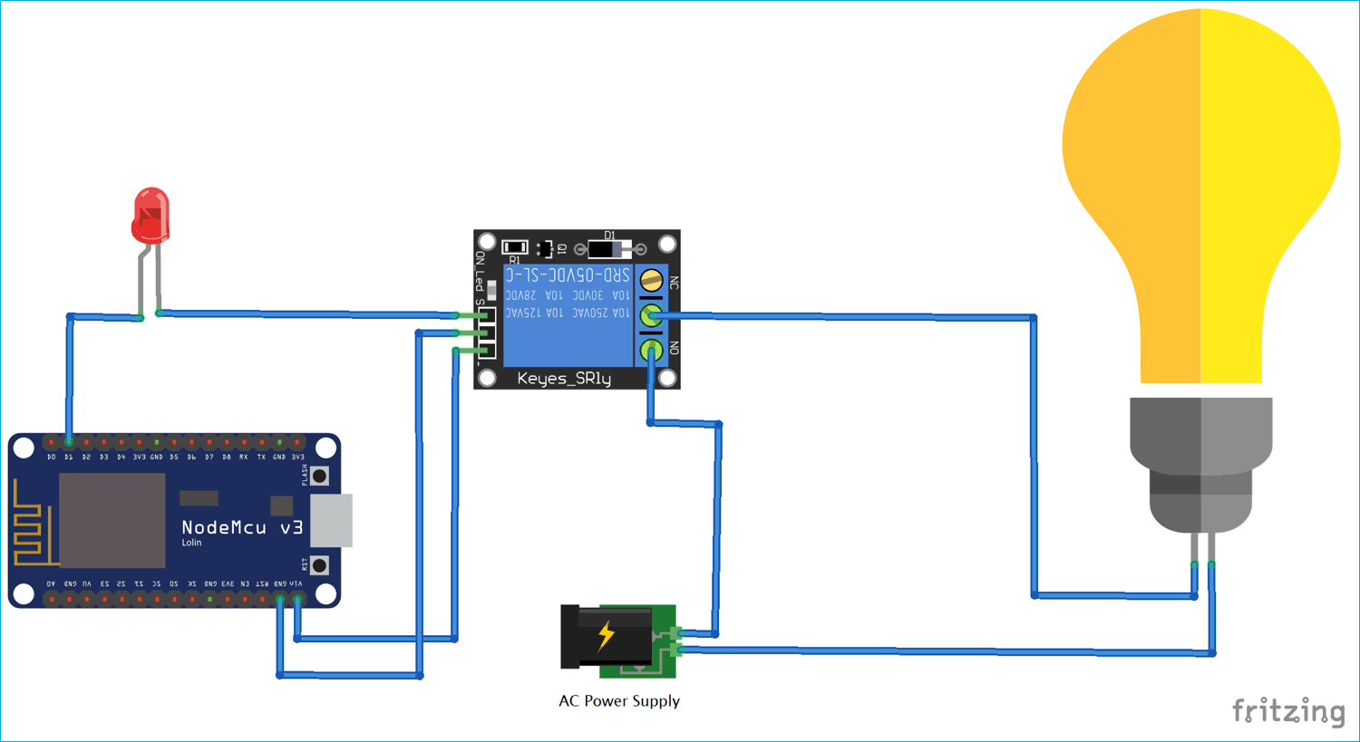

1. BLOCK DIAGRAM

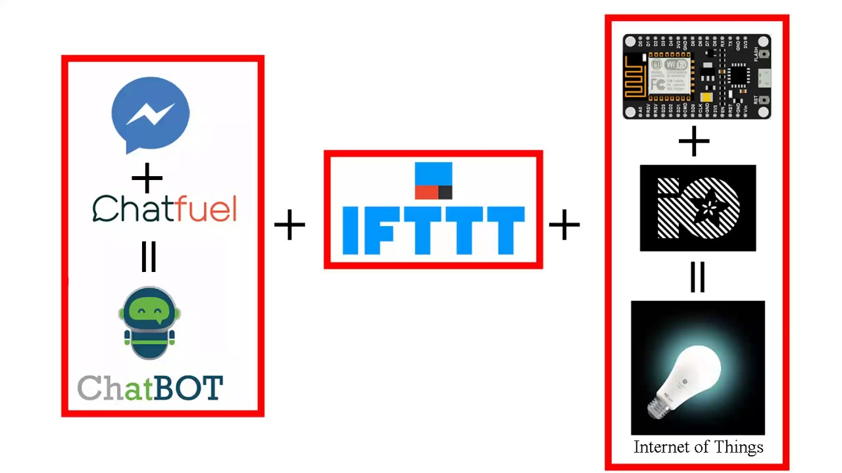

screenshots

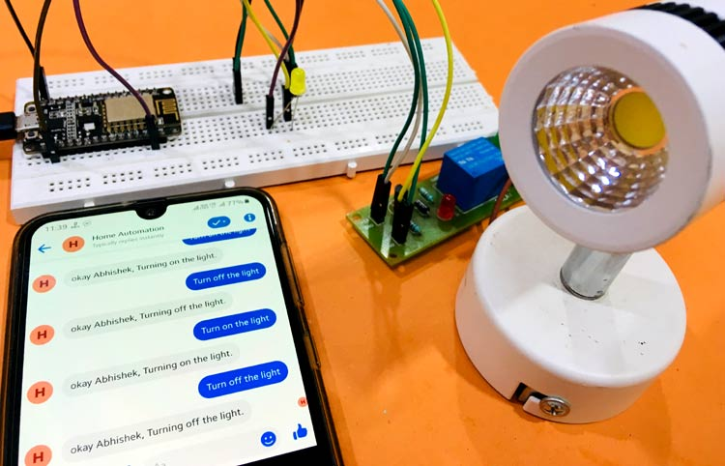

**IMPLEMENTATION**

**INTRODUCTION TO NodeMCU ESP8266**

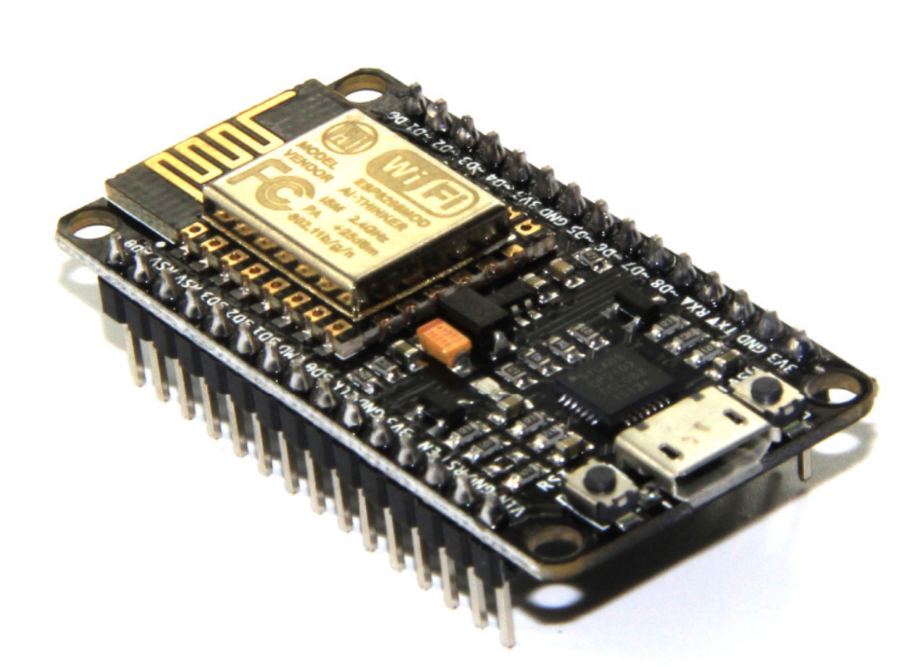NodeMCU is an open-source firmware and development kit that helps you to prototype or build IoT product. It includes firmware which runs on the ESP8266 Wi-Fi SoC from Espressif Systems, and hardware which is based on the ESP-12 module. The firmware uses the Lua scripting language. It is based on the eLua project, and built on the Espressif Non-OS SDK for ESP8266.

**TOOLS USED**

* ARDUINO IDE
* NodeMCU ESP8266
* Relay
* Breadboard
* Chatfuel
* Facebook Messenger
* IFTTT
* Adafruit IO
* MQTT

**ARDUINO IDE**

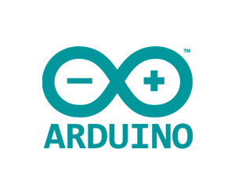[Arduino](http://arduino.cc/) is an open-source platform used for building electronics projects. Arduino consists of both a physical programmable circuit board (often referred to as a [microcontroller](http://en.wikipedia.org/wiki/Microcontroller)) and a piece of [software](http://arduino.cc/en/Main/Software), or IDE (Integrated Development Environment) that runs on your computer, used to write and upload computer code to the physical board.

The Arduino platform has become quite popular with people just starting out with electronics, and for good reason. Unlike most previous programmable circuit boards, the Arduino does not need a separate piece of hardware (called a programmer) in order to load new code onto the board -- you can simply use a USB cable. Additionally, the Arduino IDE uses a simplified version of C++, making it easier to learn to program. Finally, Arduino provides a standard form factor that breaks out the functions of the micro-controller into a more accessible package.

**NodeMCU ESP8266**

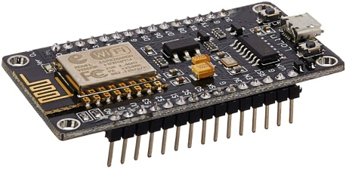NodeMCU is an open-source firmware and development kit that helps you to prototype or build IoT product. It includes firmware which runs on the ESP8266 Wi-Fi SoC from Espressif Systems, and hardware which is based on the ESP-12 module. The firmware uses the Lua scripting language. It is based on the eLua project, and built on the Espressif Non-OS SDK for ESP8266

**Relay**

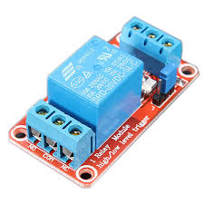A relay is an electromagnetic switch operated by a relatively small electric current that can turn on or off a much larger electric current. The heart of a relay is an electromagnet (a coil of wire that becomes a temporary magnet when electricity flows through it). You can think of a relay as a kind of electric lever: switch it on with a tiny current and it switches on ("leverages") another appliance using a much bigger current. Why is that useful? As the name suggests, many sensors are incredibly *sensitive* pieces of electronic equipment and produce only small electric currents. But often we need them to drive bigger pieces of apparatus that use bigger currents. Relays bridge the gap, making it possible for small currents to activate larger ones. That means relays can work either as switches (turning things on and off) or as amplifiers (converting small currents into larger ones).

**Breadboard**

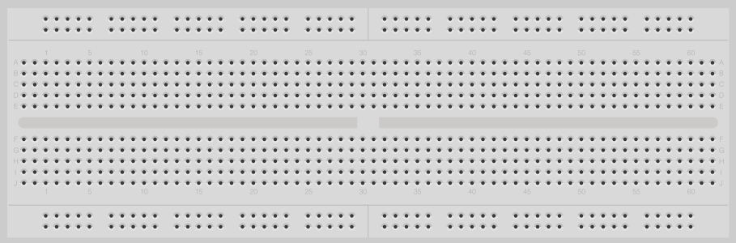

A breadboard is a solderless device for temporary prototype with electronics and test circuit designs. Most electronic components in electronic circuits can be interconnected by inserting their leads or terminals into the holes and then making connections through wires where appropriate. The breadboard has strips of metal underneath the board and connect the holes on the top of the board. The metal strips are laid out as shown below. Note that the top and bottom rows of holes are connected horizontally and split in the middle while the remaining holes are connected vertically.

**Chatfuel**

**chatfuel.jpg**Chatfuel is a user-friendly bot-building platform that lets you create AI chatbots on FB messenger without IT skills. Chatfuel provides AI automation to help your bot understand the chat messages your users send. You can choose from multiple languages to set the bot in your target language. Bots are built from components, and they can contain anything from a simple text message or image to other plugins which allow more advanced actions. In order to build a flow, you'd need to connect each component. Similarly to other chatbot platforms, Chatfuel provides a visitor dashboard and a live chat feature.

**Facebook Messenger**

****Facebook Messenger is a messaging app and a platform which was developed by Facebook. People generally use it to send text, share photos/videos and even make voice or video calls. Regular chats and voice/video chats can be started between individuals or in groups.

### **IFTTT**

 [IFTTT](https://iotdesignpro.com/tags/ifttt) stands for IF THIS THAN THAT. It is a free web-based service that allows connecting to web services, applications and devices such as Google, Facebook, Adafruit, Webhooks, Telegram, etc. to automate the tasks. Applets help to combine two services using a trigger and an action. It simply means if something is triggered in one web service then an action will take place in other web service.

### **Adafruit IO**

[Adafruit IO](https://iotdesignpro.com/tags/adafruit-io) is a server by Adafruit Industries. It is a platform for interacting with IOT devices using HTTP and MQTT protocols which helps to store and view data and also helps in controlling the devices.

### **MQTT**

[MQTT](https://iotdesignpro.com/tags/mqtt) stands for Message Query Telemetry Transport. MQTT is a TCP/IP based publish and subscribe protocol which is designed for lightweight machine to machine interactions with IOT devices. These devices act as the client who communicates to the server known as broker. A broker is a server which allows clients to send short messages to the broker and receive messages if they are subscribed to certain topic. It acts as a server that handles all the information of the devices that are connected to the server. A client can be either publisher (sending data from device to the server) or subscriber (getting data from the server to the device) of information simultaneously.

**FUTURE SCOPE AND MONOTIZATION**

We are entering an era in human history where the cheapest computer costs $9 and your kindergartener just used an Arduino to water the plants.

The Internet of Things has become one of the hottest topics in tech and everyone from Cisco to IBM to Microsoft has jumped on the bandwagon. The next phase for the Home automation market will occur based on a few key improvements in the technology available in Automation, such as improvement in Wireless Automation solutions as well as lowering of price points as the market begins to accept Home automation usage in larger volumes. Some trends that we foresee for this phase of the industry are

*Big companies like Philips, Siemens & Schneider will eventually bring out fairly mass market automation products with appealing user interface but at a lower price point than today, and more people will be able to afford the products.*

Solution offerings will slowly move to a more user friendly design, where aside from a few key components, users will be able to buy and use the Automation products themselves without the aid of any technical expert.

Here are several service model strategies that should be considered:

**Implementation & Monitoring :-**  We will provide a Smart Home solution, with a 24x7 professional monitoring service along with options for both broadband/Wi-Fi and cellular backup connections.

**Smart Home Analytics :-** Consumers are growing more flexible to free apps, but by aggregating and processing the right kind of data from a unique combination of devices, a Smart Home-based analytics service could deliver insights, such as energy usage, valuable enough to warrant a monthly service fee. Premium analytical reports to the user can be provided, if a premium account is brought by the user.

**Collaboration with an MNC** :- NodeMCU ESP8266 will be embedded with the finished product of the MNC and sold of to the user.

**Warranty & other Services** :- 1 year assured warranty, and free service will be provided. Extended warrant & free 24x7 home service can be brought by the users according to their will.

**Collaboration with Gov Projects** :- Since the product guarantees assured energy consumption, government projects can be managed.

**Selling of prototype** :- Prototype can be sold of to big MNC’s on copyright issues.

**CONCLUSION**

The home automation system has been experimentally proven to work satisfactorily by connecting sample appliances to it and the appliances were successfully controlled from a wireless mobile device. We learned many skills such as soldering, wiring the circuit and other tools that we use for this project and was able to work together as a team during this project.

**BIBLIOGRAPHY**

* <https://iotdesignpro.com/projects/facebook-controlled-home-automation-using-esp8266-nodemcu>
* [www.youtube.com](http://www.youtube.com)
* IEEE community support
* ESP8266 home automation projects Catalin Batrinu